**Common types of collisions between**

**bicycles and motor vehicles**

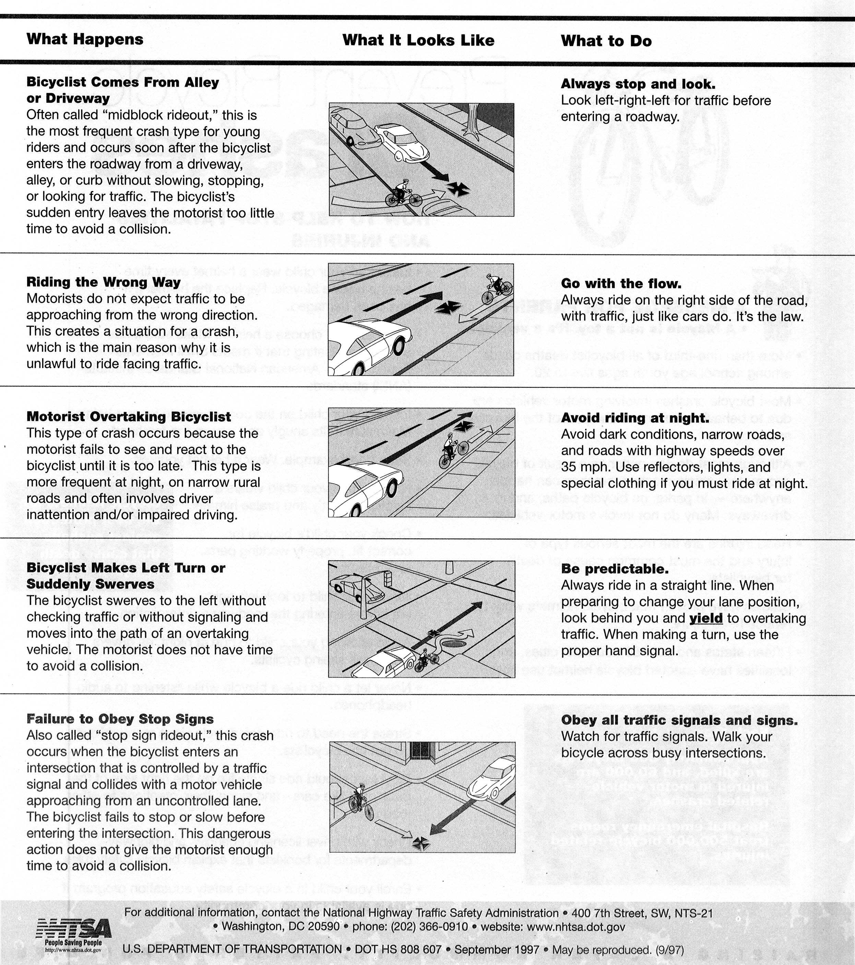

 For more information on bicycle safety, visit the National Highway Traffic Safety Administration

(NHTSA) Web site at: ww.nhtsa.dot.gov Taken from DOT HS 810 000 – April, 2007