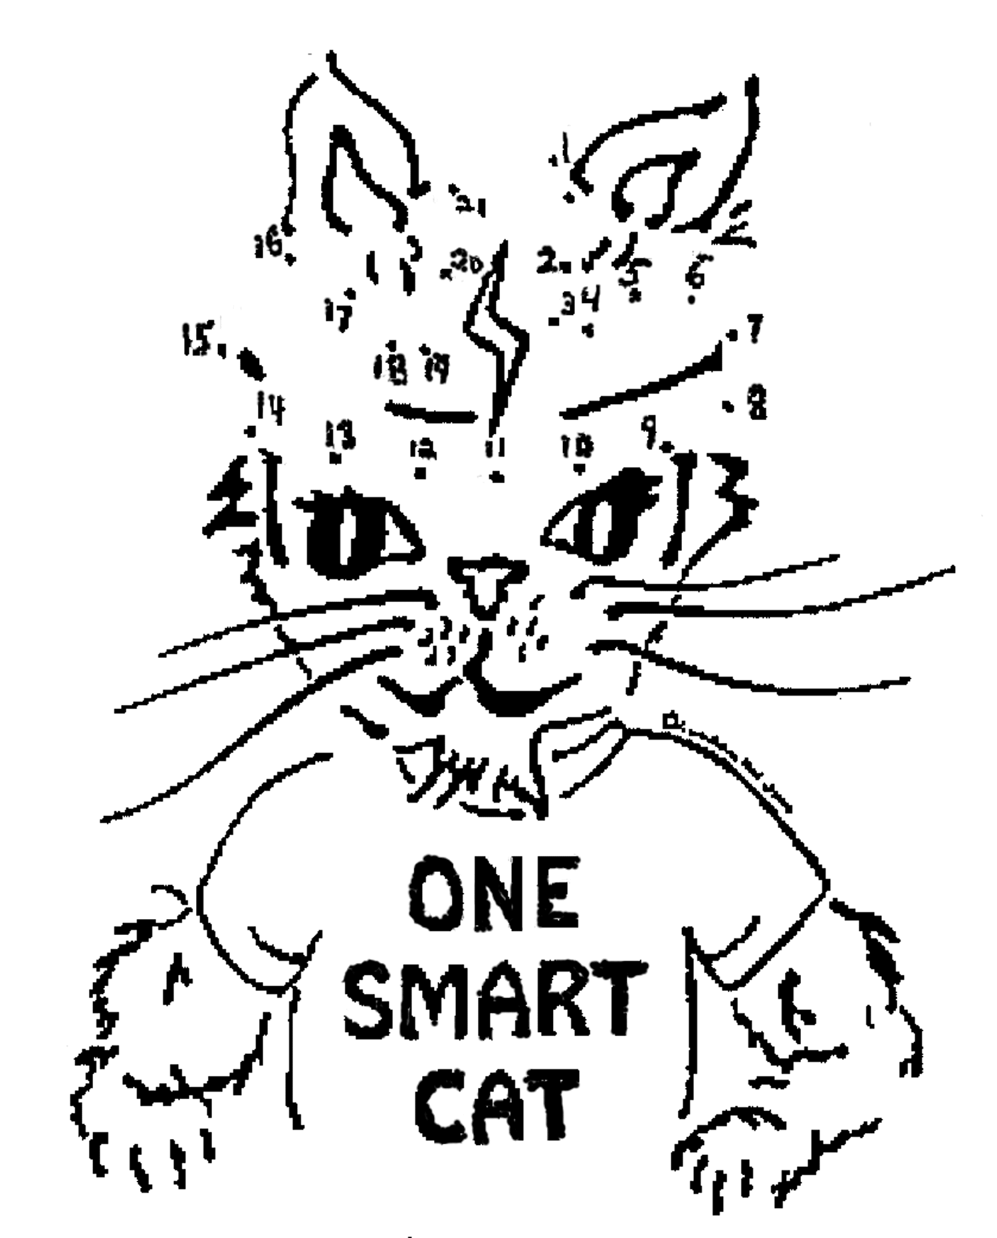
One Smart Cat Says

Protect
your head!

Wear a helmet
when you
ride a bike!

Connect the dots to see what O.S. Cat
wears on every bike ride.

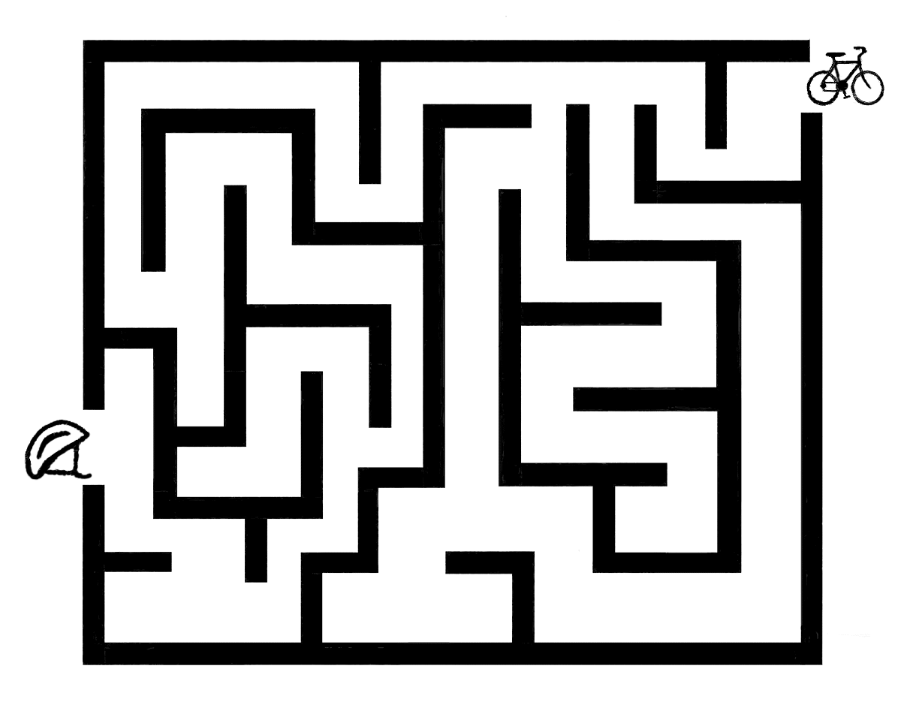

Find your way through this maze to
connect the helmet with the bicycle.

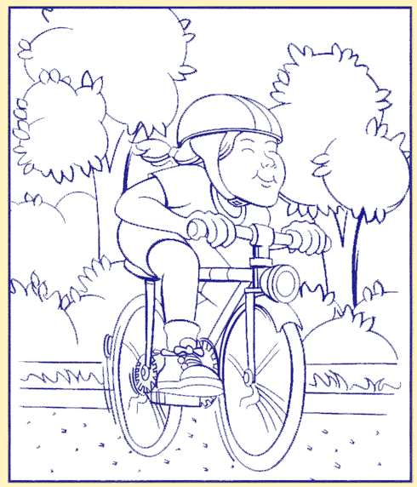

Ride safely and wear your helmet.

